**Lab worksheet 2: Numerical Data**

Q1.

Code:

|  |
| --- |
| ***package Q_01;   public class Q_01 {  public static void main(String[] args) {   int A=2,B=4,C=6,X=2,Y=8,r=5;   //Q_01_a  double Square_root1 = Math.sqrt(B * B + 4 * A * C);  System.out.println("Square root of B^2+4AC is :" + Square_root1);  //Q_01_b  double Square_root2 = Math.sqrt(X + 4 * Math.pow(Y, 3));  System.out.println("Square root of X + 4Y^3 : " + Square_root2 );  //Q_01_c  double cube_root = Math.cbrt(X * Y);  System.out.println("Cube root of the product of X and Y : " + cube_root);  //Q_01_d  double area = Math.PI * Math.pow(r, 2);  System.out.println("Area of a circle :" + area);   }  }*** |

Output:

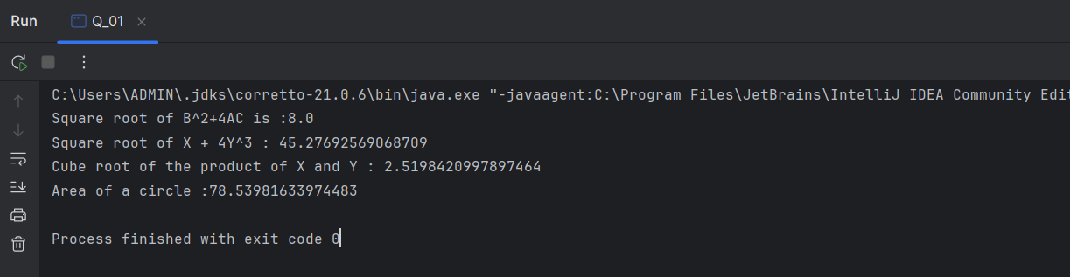

Q2.

Code:

|  |
| --- |
| ***package Q_02;***  ***import java.util.Scanner;***  ***public class Q_02{***  ***public static void main(String[] args) {***  ***Scanner scanner = new Scanner(System.in);***  ***System.out.print("Enter length in centimeters: ");***  ***double centimeters = scanner.nextDouble();***  ***double inches = centimeters / 2.54;***  ***int feet = (int) (inches / 12);***  ***double remainingInches = inches % 12;***  ***System.out.println(centimeters + " cm is equivalent to " + feet + " feet and " + remainingInches + " inches.");***  ***scanner.close();***  ***}***  ***}*** |

Output:

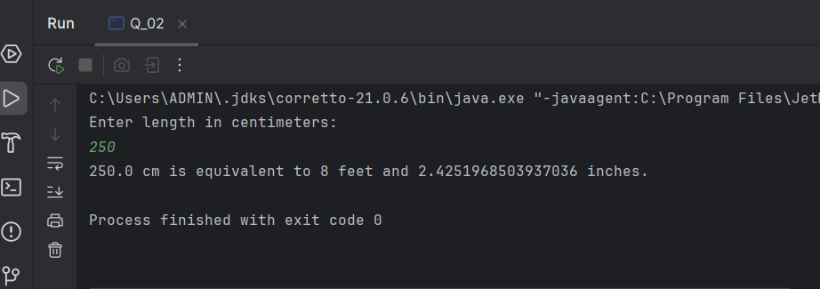

Q3.

Code:

|  |
| --- |
| ***package Q_03;   import java.util.Scanner;   public class Q_03 {  public static void main(String[] args) {   Scanner scanner = new Scanner(System.in);   System.out.print("Enter temperature in degrees Celsius: ");  double celsius = scanner.nextDouble();   double fahrenheit = (1.8 * celsius) + 32;   System.out.println(celsius + " degrees Celsius is equivalent to " + fahrenheit + " degrees Fahrenheit.");    scanner.close();  }  }*** |

Output:

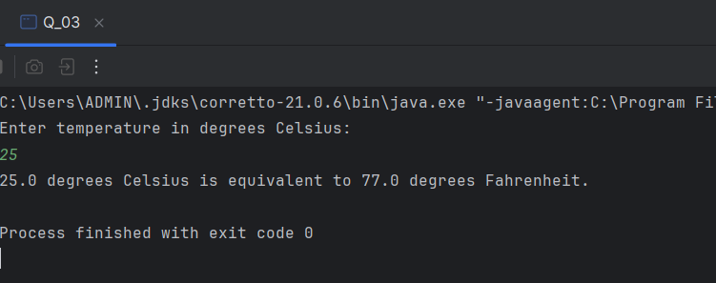

Q4.

Code

|  |
| --- |
| ***package Q_04;***  ***import java.util.Scanner;***  ***public class Q_04 {***  ***public static void main(String[] args) {***  ***Scanner scanner = new Scanner(System.in);***  ***System.out.print("Enter your weight in pounds: ");***  ***double bodyWeight = scanner.nextDouble();***  ***double calories = bodyWeight * 19;***  ***System.out.println("You need " + calories + " calories per day.");***  ***scanner.close();***  ***}***  ***}*** |

Output:

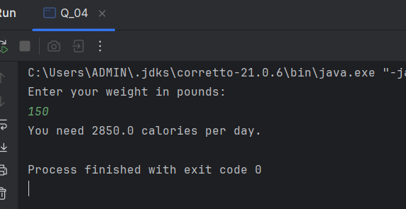

Q5.

Code

|  |
| --- |
| ***package Q_05;***  ***import java.util.Scanner;***  ***public class Q_05 {***  ***public static void main(String[] args) {***  ***Scanner scanner = new Scanner(System.in);***  ***System.out.print("Enter temperature in degrees Fahrenheit: ");***  ***double fahrenheit = scanner.nextDouble();***  ***double celsius = (5.0 / 9.0) * (fahrenheit - 32);***  ***System.out.println(fahrenheit + " degrees Fahrenheit is equivalent to " + celsius + " degrees Celsius.");***  ***scanner.close();***  ***}***  ***}*** |

Output:

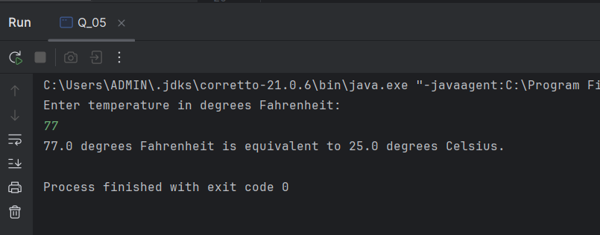

Q6

Code:

|  |
| --- |
| ***package Q_06; import java.util.Scanner;  public class Q_06 {  public static void main(String[] args) {  Scanner scanner= new Scanner(System.in);   System.out.println("enter born year:");  int year=scanner.nextInt();   int age= 2008-year;   System.out.println("You were born in "+year+" and will be (are) "+age+" this year.");   } }*** |

Output:

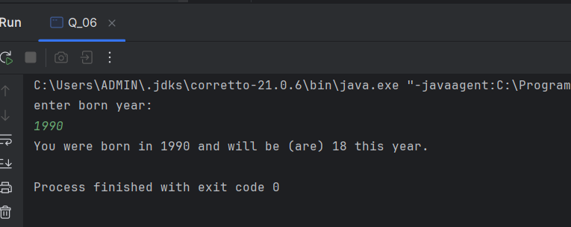

Q7.

Code.

|  |
| --- |
| ***package Q_07; import java.util.Scanner;  public class Q_07 {  public static void main(String[] args) {   Scanner scanner = new Scanner(System.in);   System.out.print("Enter your weight in kilograms: ");  int weight = scanner.nextInt();   System.out.print("Enter your height in centimeters: ");  int height = scanner.nextInt();   double heightInMeters = height / 100.0; // Convert height to meters  double bmi = weight / (heightInMeters * heightInMeters); // BMI formula   System.out.printf("Your BMI is: %.2f%n", bmi);   scanner.close();  } }*** |

Output:

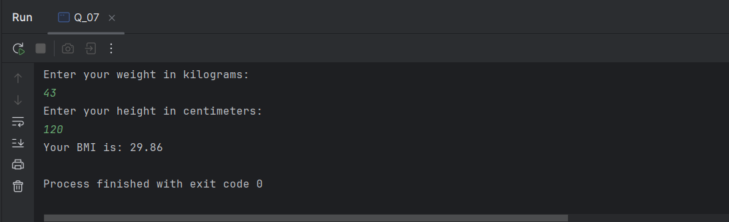

Q8.

Code.

|  |
| --- |
| ***package Q_08; import java.util.Scanner;  public class Q_08 {  public static void main(String[] args) {   Scanner scanner = new Scanner(System.in);   System.out.print("Enter the radius of the sphere: ");  double radius = scanner.nextDouble();   double volume = (4.0 / 3.0) * (3.14 * Math.pow(radius, 3));   System.out.printf("The volume of the sphere with radius %.2f is: %.2f%n", radius, volume);    scanner.close();  } }*** |

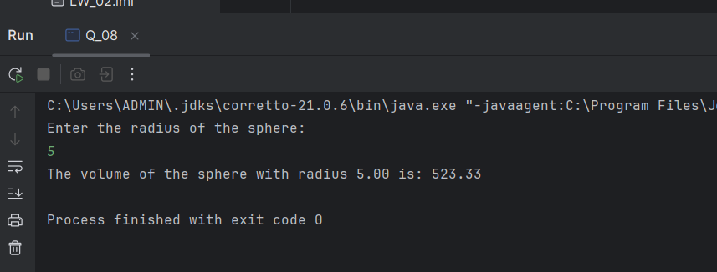

Q9.

Code.

|  |
| --- |
| ***package Q_09;  import java.util.Scanner;  public class Q_09 {  public static void main(String[] args) {  Scanner scanner = new Scanner(System.in);   System.out.print("Enter the principal amount (P): ");  double principal = scanner.nextDouble();   System.out.print("Enter the interest rate (R) in percent: ");  double rate = scanner.nextDouble();   System.out.print("Enter the number of years (N): ");  int years = scanner.nextInt();   double amount = principal * Math.pow(1 + (rate / 100), years);  double moneyEarned = amount - principal;   System.out.printf("The amount after %d years is: %.2f%n", years, amount);  System.out.printf("The money earned after %d years is: %.2f%n", years, moneyEarned);   scanner.close();  } }*** |

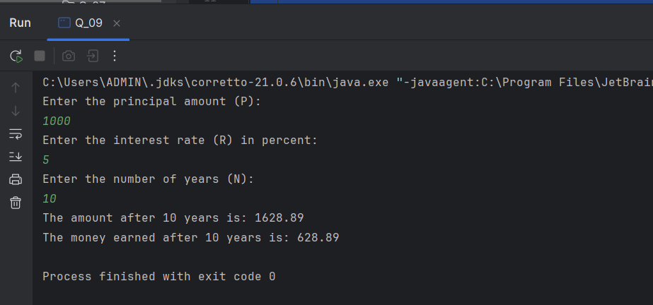

Q10.

Code.

|  |
| --- |
| ***package Q_10;  import java.util.Scanner;  public class Q_10 {  public static void main(String[] args) {  final int MONTHS_IN_YEAR = 12;   Scanner scanner = new Scanner(System.in);   System.out.print("Enter the loan amount: ");  double loanAmount = scanner.nextDouble();  System.out.print("Enter the annual interest rate (in percent): ");  double annualInterestRate = scanner.nextDouble();  System.out.print("Enter the loan period (in years): ");  int loanPeriod = scanner.nextInt();   double monthlyInterestRate = annualInterestRate / 100.0 / MONTHS_IN_YEAR;   int numberOfPayments = loanPeriod * MONTHS_IN_YEAR;   double monthlyPayment = (loanAmount * monthlyInterestRate) /  (1 - Math.pow(1 / (1 + monthlyInterestRate), numberOfPayments));   double totalPayment = monthlyPayment * numberOfPayments;  System.out.printf("Monthly Payment: %.2f%n", monthlyPayment);  System.out.printf("Total Payment: %.2f%n", totalPayment);   scanner.close();  } }*** |

Output:

